SHORTEST PATH USING DIJKSTRA ALGORITHM

Maja Erkechova¹
Jozef Stefan International Postgraduate School, Ljubljana, Slovenia¹
erkechova@gmail.com

Abstract: This study is based on Dijkstra’s algorithm as the most well-known algorithm in the shortest path problem. The problem receives its attention for its wide applicability in many areas especially with the technology advancing and the need for more improved versions of the already existing algorithms. The Google Maps application, which we use to find the distance between one city or another, or from our location to a desired location, encounters the shortest path problem where there are many routes connecting the defined locations but the shortest one is always presented. Nowadays, automated robots and drones are programmed with a solution to the shortest path problem to deliver packages to a specific location. Also, in social networking applications, many social media companies implement the feature of suggesting a list of friends the user may know based on his location, again using the shortest path problem solution. For that reason, much research and improvements on the traditional Dijkstra’s algorithm have been made. This study covers an example where Dijkstra’s algorithm was implemented as well as time analysis for randomly generated graphs with a larger number of nodes.

Keywords: dijkstra, shortest path, implementation

Introduction
The shortest path problem is the classical problem in the graph theory study, aiming to find the shortest path between two nodes in a graph. The most common algorithms of graph-based shortest path finding are Dijkstra’s Algorithm, Bellman-Ford algorithm, Floyd-Warshall algorithm, Johnson’s algorithm, etc. Dijkstra’s Algorithm was invented by a Dutch scientist Edsger Wybe Dijkstra in 1959. This algorithm has been successfully applied in many fields like robot path planning, guiding driver systems, geographic information science, transportation, etc. The traditional Dijkstra is simple, easily implemented, and adaptable to changes. For a given node in a graph, the algorithm calculates the weight of the shortest path from starting node to the destination node. Once the shortest path reaches the destination node the algorithm is then stopped. However, there are many improved versions of the algorithm, being applied in different areas and tackling a variety of disadvantages. Authors in [1] categorize the improvements of the traditional Dijkstra in three groups: to analyze the space complexity of the algorithm and to improve storage efficiency and save space; to analyze and improve the time complexity; and to enrich the application field of the algorithm. They focus on extending the Dijkstra to find the optimal and more accurate path on a curved surface. Authors in [2] propose an effective model using Dijkstra for robot path-planning to pass the obstacles and find the shortest path from the starting point to the target. D. Guo et al. [3] improved the traditional Dijkstra, combining it with vehicle fuel consumption and emission model to reduce fuel consumption and emission while driving. Authors in [4] also focus on finding the shortest path problem for car navigation systems while driving, considering the attributes of the intersections. For the addressed problem, they propose reverse labeling Dijkstra combined with BFS, stack, and queue data structures. The authors in [5] aim at improving the efficiency of the path search by reducing the computational time. Classical Dijkstra time complexity is $O(V^{2})$ and a large number of graph nodes leads to a large number of search process operations. The search process is done without considering the direction of the destination node; therefore the authors propose priority target regions to narrow the search. G. Qing et al. [6] focus on the automated storage and retrieval system. They base to improve the model based on the fact that the traditional Dijkstra only finds one shortest path and skips over other paths with the same distance if there are any. For that reason, they propose a model that solves the path planning problem with several shortest paths depending on the shortest distance and the shortest time. Similarly, authors in [7] extended the algorithm to solve the shortest path problem with fuzzy edge lengths, addressing the issues of how to determine the addition of two edges and how to compare the distance between two different paths when their edges length are represented by fuzzy numbers. A great in-depth literature review of Dijkstra’s algorithm can be found in [1]. The many different approaches of improving the traditional Dijkstra in many different ways prove its advantage of adaptability to changes.
This study is structured as follows. A detailed explanation of Dijkstra and other shortest path methods is described in Section 2. Section 3 describes the example and the implementation of Dijkstra as well as a discussion. Section 4 explains the time analysis of Dijkstra while the conclusion of the study is presented in Section 5.

Methods

Dijkstra’s Algorithm
The Dijkstra algorithm first starts with the starting node and calculates the shortest path to its adjacent nodes. In the beginning, the distance to the destination node is set to zero. Then, for each unvisited node from the current one, the weight of the edge is added and the distance from the current node to the destination is updated. The chosen terminal node with the smallest distance recorded then becomes the intermediate node. The algorithm then searches for the next shortest path to its adjacent nodes and the iteration continues until every node is crossed. After reaching the destination node, the algorithm stops and delivers the shortest path found. It is important to note that Dijkstra places one constraint on the graph: there can be no negative edge weights. The mathematics of Dijkstra’s algorithm is presented next.
A weighted graph can be presented as $G=(V,E,W)$ where $v_{1}, v_{2}, v_{3}, …, v_{n} ∈V$ are the nodes; $e_{1},e_{2}, e_{3}, …,e_{n} ∈E$ are the edges (the path connecting $v_{i-1}$ with$v_{i}$ ); and $w_{\left(i-1\right)i}$ is the edge weight. $A$ is a matrix of the weighted graph. If there is an edge between $v_{i}$ to $v_{j}$ then $a_{ij}=w_{ij}$; if there isn’t then $a_{ij}=∞$; and if $i=j$ then $a_{ij}=0.$ $S$ is a set of nodes where the shortest path is stored. Each component $D\left[i\right]$ of the vector $D$ presents the current distance length of the shortest path from the initial node to each destination.
Dijkstra’s steps can be described as follows:
- Initialize $S$ and $D$:
$$S=\left\{v_{1}\right\}, D=A\left[1\right]\left[i\right], i=1,2,3,…,n;$$
- Choose $v_{j}$ satisfying $D\left[j\right]=min⁡\{D[i]|v_{i}∈V-S\}$, let $S∪\left\{v_{j}\right\}$;
- Change the shortest path length from $v_{1}$ to $v_{k}$ in the set $V-S$. If $D\left[j\right]+A\left[j\right]\left[k\right]<D[k]$, then change $D\left[k\right]=D\left[j\right]+A\left[j\right][k]$;
- Repeat Step 2 and Step 3 $n-1$ times, then the shortest path from $v_{1}$(the starting node) to $v_{j}$(the destination node) can be found. Then, the starting node, the intermediate nodes, and the destination terminal node are output in a sequence.
Figure 1 presents an example of a simple graph including five nodes. Using Dijkstra, the resulted shortest path from starting node C to destination node E is C-A-B-E with a distance of 5. Step by step calculations are explained in the next paragraph.
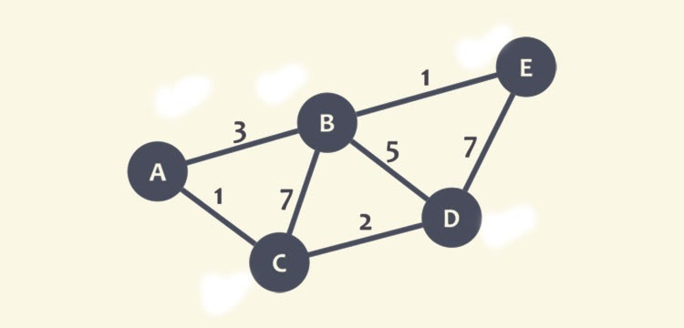
Figure 1 Example of traditional Dijkstra algorithm [11].
Node C is first marked as a current node and all neighbors are checked and their distanced updated from infinity as well. C is then marked as visited and A is chosen next with the lowest minimum distance. Then, all neighbors are checked and the distance to B is updated to 4 as a lower distance than the previously marked 7. After this, A is marked as visited and D is taken as a current node because it is unvisited with a smallest recent distance. From node D to B distance is calculated 2+5=7 but since 7>4 the distance to B is kept as 4. Then, the current node is set to B and the distance from B to E is calculated 4+1=5 and compared with the previously assigned distance to E and as 5<9, the distance to E is updated to 5. Afterwards, node E is marked as a current node and since it does not have any unvisited neighbors and it is the destination node, the algorithm finishes with giving the sequence of the shortest path. The step by step calculation is shown in Figure 2.
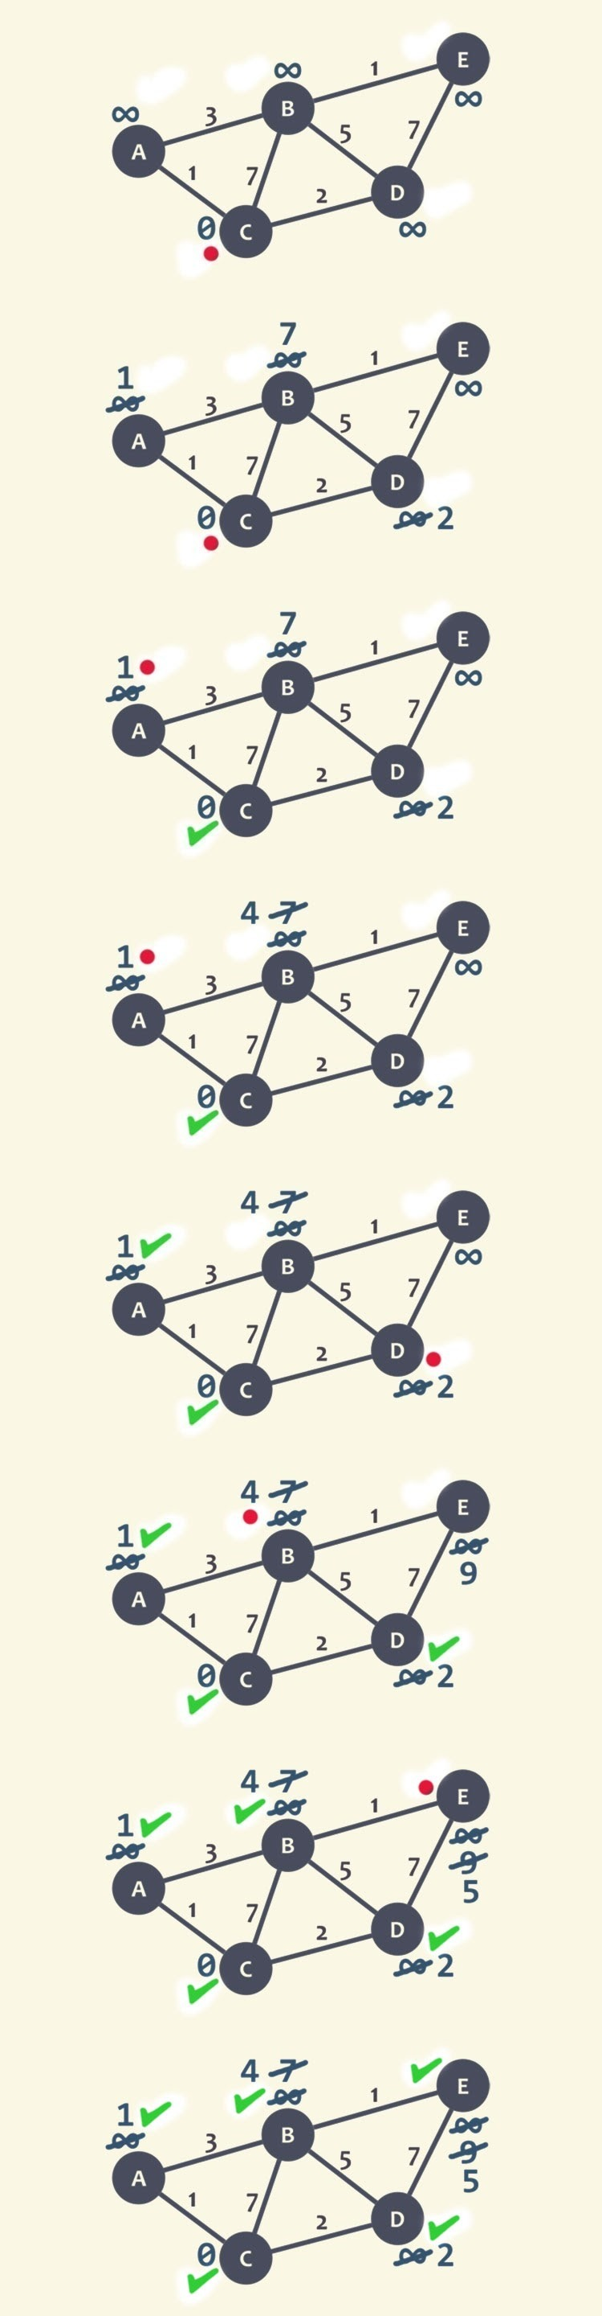
Figure 2 Dijkstra's algorithm step by step calculation [11].

Other shortest path algorithms
Similar to Dijkstra’s algorithm, the Bellman-Ford algorithm is known for its purpose to find the shortest path between a given node and all other nodes in the graph. Though it is slower than Dijkstra, it makes up for its disadvantage with the capability of handling graphs in which some of the edge weights are negative. The Bellman-Ford algorithm’s time complexity is $O(VE)$ [8].
The Floyd-Warshall algorithm stands out for not being a single-source algorithm like Dijkstra and Bellmand-Ford. That means it calculates the shortest distance between every pair of nodes in the graph rather than only calculating from a single node. It works by breaking the problem into smaller ones and then combining the answers to solve the main shortest path issue. The Floyd-Warshall algorithm solves the shortest path problem in $O(V^{3})$and is typically faster on dense graphs (graphs with nearly a maximum number of edges possible) [8].
Johnson’s algorithm varies from the rest algorithms as it relies on two other algorithms to determine the shortest path. First, it uses Bellman-Ford to detect negative cycles and eliminate any negative edges. Then, it relies on Dijkstra’s algorithm to calculate the shortest path. It works best with sparse graphs (graphs with about as many edges as nodes) since its runtime depends on the number of edges. Johnson’s algorithm has a time complexity of $O(VE+V^{2}logV)$ [8].
More often, the best algorithm to use is dependent upon the type of graph and the shortest path problem that is being solved. Generally, for graphs with negative edge weights, the problem would be solved with Bellman-Ford algorithm. For dense graphs and all-pairs problem (finding the shortest paths between all pairs of nodes in a graph), Floyd-Warshall would be useful. For sparse graphs and all-pairs problem, Johnson’s algorithm would do the job but if there are no negative edge weights, then it is better to use Dijkstra’s algorithm for memory efficiency. Dijkstra algorithm’s time complexity is faster than Bellman-Ford algorithm, but Dijkstra cannot be used to solve graphs with negative edge weights. From a space complexity perspective, many of these algorithms are the same in their most fundamental forms. However, when these algorithms are advanced, the space required to perform the algorithm increases and is often traded for speed.

Application
The following paragraph explains the created example on which the Dijkstra’s algorithm is implemented.

Problem – Europe trip
The Smith family is planning a two months tour across Europe for the summer holidays. The father, Joseph, just bought a new car and he is looking forward to testing its performance out and enjoying driving it along the trip. Their starting city is Rome, where they currently live, and the destination city is Stockholm. For their trip, Joseph would like to take only one ferry ride on the way to Stockholm since the tickets can be very expensive. As they recently moved to Europe and do not know much about the capitals nor which would they like to visit, they are open to options but they would like to see the shortest route so they can spend more time visiting the cities and less time driving. Their goal is to find an interesting route to Stockholm which they will follow for the way back too.

Implementation of algorithm
The problem can be presented as an undirected graph, where each capital is a node and the distance between two capitals is the edge weight. The distance between two capitals is taken from the recommended route shown on Google Maps, which most of the time is the fastest one. Some of the routes are missed because the route to the destination city would pass through another capital (for example: Riga-Berlin is missed because the route suggests passing through Warsaw and the total distance is a sum of Riga-Warsaw + Warsaw-Berlin; Rome-Zagreb is missed because the route suggests passing through Ljubljana and the total distance is a sum of Rome-Ljubljana + Ljubljana-Zagreb). The resulting graph is shown on Figure 3.
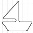
The graph consists of a total of 20 nodes and 39 edges with assigned edge weights. The symbol attached on some of the edges means that the route includes a ferry ride. The graph was drawn in the Lucidchart platform.
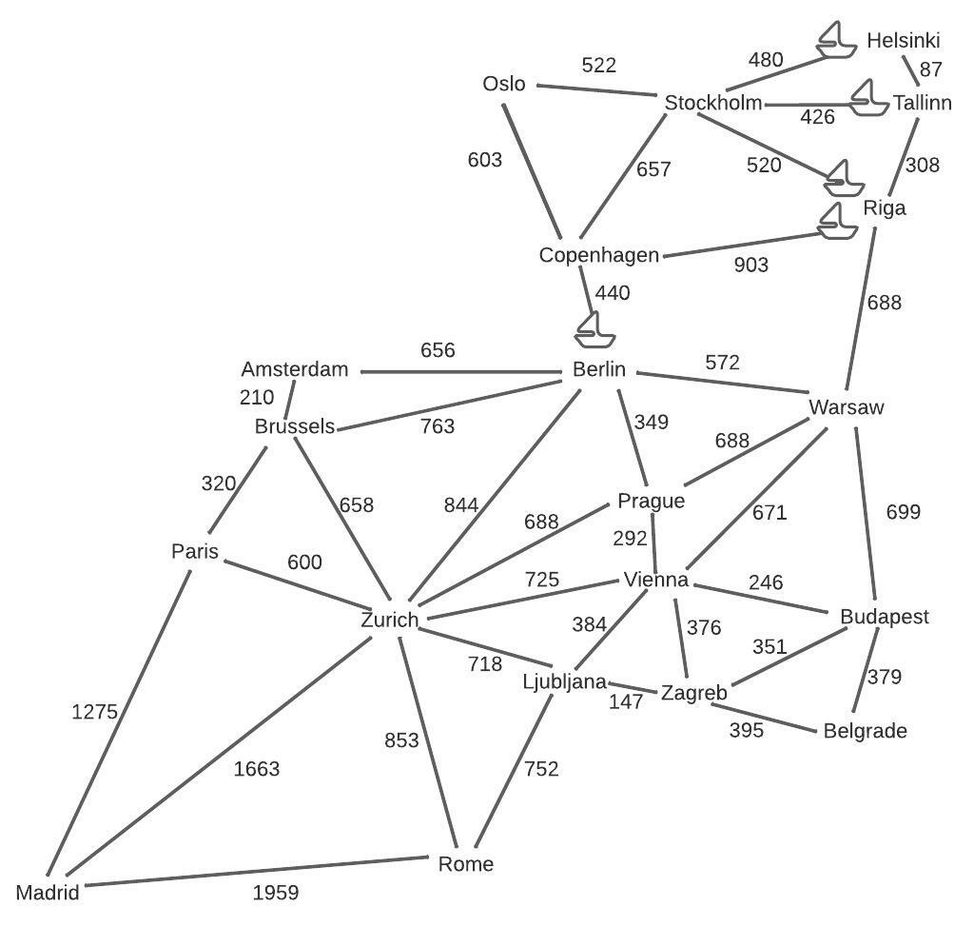
Figure 3 Europe trip graph presentation.
The implementation the algorithm is carried out using Python programming language. After running the algorithm, the shortest path that Dijkstra calculated is: Rome-Zurich-Berlin-Copenhagen-Stockholm, with a total distance of 2794$km$.
The core of the algorithm is the dijkstra function where the shortest path is calculated and the starting node is set as a current node. From the current node, all the unvisited neighbours are considered and their distances are calculated. When all the neighbours are considered, the current node is marked as visited and removed from the unvisited list. This continues until there is no unvisited node. Then, the target node is set and all the predecessors are gathered.
Dijkstra’s running time depends on how the operations are implemented. In this study, the algorithm first uses a priority queue. A priority queue is an abstract data type which is like a regular queue or stack data structure, but it differs from the “first come first served” policy with the additional priority in which the elements are served. It can be called a sorted data structure where the elements are stored by priority, and in this case the priority is the lower distance between the nodes.
While priority queues are often implemented with heaps, they are conceptually different from heaps. A heap is a kind of binary tree, where each node, except for the root node, has a parent node. Heaps are known for its maximally efficient implementation of a priority queue. When a heap is used to implement a priority queue, each node contains one of the items in the queue along with the number that specifies the priority of that item [9]. A heap must satisfy the min/max heap property: the value of each node is greater/less than or equal to the value of its parent.
The time needed to execute the Dijkstra algorithm with a priority queue is 0.004996061325073242 seconds. It can be noticed that the time needed is very short because the graph has a small number of nodes and edges compared to real examples. For a comparison, the same Dijkstra’s algorithm but with heapq was also implemented, and the time needed to execute the algorithm is 0.002999544143676758 seconds. Although the time was already too short, heapq shortens it in half.

Discussion
When creating the problem, there were several constraints that were intended to be part of the problem, but were impossible to implement for this step of the study. In the current situation, those can be seen as limitations to Dijkstra.
The first one was to add a limitation to the number of nodes in the shortest path. The idea was: ‘His children, Ana 18 and Jin 21, agreed to take the tour with their parents under one condition, they would like to visit more than 5 cities’. The second idea was similar to the first one, but to add a limitation to the total distance (that is the total edge weight), saying: ‘Joseph and his wife agree on visiting at least 5 cities but would not pass more than 3 500km’. Although both ideas are contradictory from Dijkstra’s algorithm core logic to simply find the shortest path between the start and destination node and another algorithm may be a more suitable option, this is an interesting area that can be a focus of future work for this study.
The third idea was to give two more path options along with the shortest path, in the form of: ‘The Smith family is open to options and would like to see two more recommendations along with the shortest route. From the recommendations, they will choose which one they would like the most’. Dijkstra can only give one shortest path from the start to the destination node. Especially in real examples, this option is important and very commonly asked. Z. Wang et al. [10] specifically worked on this creating a revised algorithm by improving the temporary label updating process to present all the shortest paths from the starting node to the destination node. Authors in [6], too, tackle and achieve solving the same problem.

Time analysis
In the second part of the study, first, random graphs with larger number of nodes are generated. The number of nodes is set in range(10, 4000)[::200]. This means 20 individual graphs with number of nodes 10, 210, 410,…, 3610, 3810. More than 4000 nodes were not used because of limited computational resources. Then, the edge weights are randomly generated using a matrix, and Dijkstra’s algorithm is then applied for a comparison between the times needed for execution for each situation. The algorithm is individually applied with a priority queue, and then with heapq. It is important to note that in this analysis, the starting node and the destination node were randomly selected.
The results are shown in Figure 4. The range of number of nodes is presented on x-axis, and the time in seconds is presented on y-axis. The blue curve presents the series of running times of Dijkstra’s algorithm using priority queue while the orange one presents the series of running times of Dijkstra’s algorithm using heapq. From its form, the blue curve looks similar to a curve of quadratic time complexity$O(n^{2})$, which corresponds to Dijkstra’s time complexity with a priority queue - $O(V^{2})$. The orange one, on the other hand, looks similar to a curve of logarithmic time complexity $O(logn)$, which then corresponds to Dijkstra’s time complexity when using binary heap - $O(\left(V+E\right)logV)$. This can serve as a base and proof of the results.
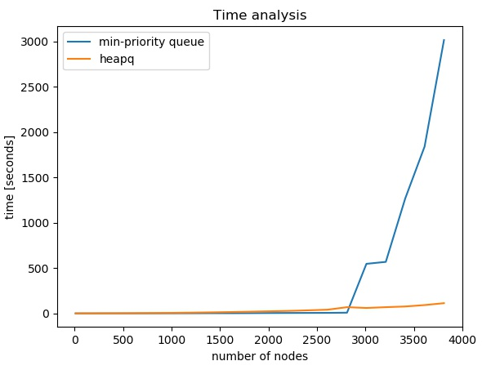
Figure 4 Results of time analysis for random generated graphs.
The running time clearly increases with the increase of the number of nodes in the graphs. What can also be noticed is that the time is very short for graphs under 2500 nodes, which correlates with the results that were achieved using the Europe trip example. In addition, there is a strange condition occurring for the running time of 3210 nodes, where the time does not increase proportionally with the increase of the number of nodes. This may happen due to variable computer resources and inconsistent graph structure, but it should be further investigated. However, generally speaking, the results of the time analysis corroborated with the results of the Europe trip example.

Conclusion
With the focus on the Dijkstra algorithm, this study covers the basics and provides an example using the algorithm to solve the shortest path Europe trip problem and a discussion for the time complexity for randomly generated graphs. Although, in real-life problems, there would be many more nodes and the traditional Dijkstra algorithm may be seen as a shoddy option, it is still an excellent foundation with a lot of space for improvement and advancement.

References

[1] M. Luo, X. Hou, and J. Yang, “Surface Optimal Path Planning Using an Extended Dijkstra Algorithm,” IEEE Access, vol. 8, pp. 147827–147838, 2020, doi: 10.1109/ACCESS.2020.3015976.
[2] H. Wang, Y. Yu, and Q. Yuan, “Application of Dijkstra algorithm in robot path-planning,” 2011 2nd Int. Conf. Mech. Autom. Control Eng. MACE 2011 - Proc., no. 2010011004, pp. 1067–1069, 2011, doi: 10.1109/MACE.2011.5987118.
[3] D. Guo et al., “A vehicle path planning method based on a dynamic traffic network that considers fuel consumption and emissions,” Sci. Total Environ., vol. 663, pp. 935–943, 2019, doi: 10.1016/j.scitotenv.2019.01.222.
[4] D. D. Zhu and J. Q. Sun, “A New Algorithm Based on Dijkstra for Vehicle Path Planning Considering Intersection Attribute,” IEEE Access, vol. 9, pp. 19761–19775, 2021, doi: 10.1109/ACCESS.2021.3053169.
[5] C. Yin and H. Wang, “Developed Dijkstra shortest path search algorithm and simulation,” 2010 Int. Conf. Comput. Des. Appl. ICCDA 2010, vol. 1, no. Iccda, pp. 116–119, 2010, doi: 10.1109/ICCDA.2010.5541129.
[6] G. Qing, Z. Zheng, and X. Yue, “Path-planning of automated guided vehicle based on improved Dijkstra algorithm,” Proc. 29th Chinese Control Decis. Conf. CCDC 2017, pp. 7138–7143, 2017, doi: 10.1109/CCDC.2017.7978471.
[7] Y. Deng, Y. Chen, Y. Zhang, and S. Mahadevan, “Fuzzy Dijkstra algorithm for shortest path problem under uncertain environment,” Appl. Soft Comput. J., vol. 12, no. 3, pp. 1231–1237, 2012, doi: 10.1016/j.asoc.2011.11.011.
[8] A. A. Tamimi, “Comparison Studies for Different Shortest path Algorithms,” Int. J. Comput. Technol., vol. 14, no. 8, pp. 5979–5986, 2015, doi: 10.24297/ijct.v14i8.1857.
[9] C. Nine, “Priority Queues and Heapsort.”
[10] Z. Wang, H. Weiyi, and Y. Li, “Shortest path problem with multiple shortest paths,” J. Harbin Inst. Technol., vol. 42, Sep. 2010.
[11] https://www.analyticssteps.com/blogs/dijkstras-algorithm-shortest-path-algorithm

