Optimizing the brute force implementation of Boids simulation using a k-d tree

Stefan Borkovski¹
Jožef Stefan International Postgraduate School, Ljubljana, Slovenia¹
stefan.borkovski@yahoo.com

Abstract The brute force implementation of Boids simulation suffers from algorithmic complexity. Calculating the distance between every boid is the slowest part of the code. It is an operation with quadratic time complexity $O\left(n^{2}\right)$ where n is the number of boids present in the simulation. In this work, the problem is addressed with the usage of a k-d tree. Unlike the exact distance calculation which takes $O\left(n^{2}\right)$, a k-d tree can be constructed in $O\left(nlogn\right)$where querying all the neighbors for an entry in the tree takes $O\left(nlogn\right)$. Improvement in the time complexity domain contributes to the ability to include more agents in the simulation and to reproduce a more realistic and natural phenomenon.

Keywords: Boids, k-d tree, search, algorithm, time complexity

Introduction
The motivation for this work can be found in the mesmerizing flow of flock of birds against the setting sun. Hundreds or even thousands of birds flying together forming endless shapes as one entity is an incredible phenomenon. In the past, people were found astonished by this event and they thought that it is governed by very complex rules. Furthermore, people thought that the flocking effect is very complex that it cannot be described mathematically. But in 1986, a computer graphic expert Craig Reynolds overcome the past thoughts and found a way to create a computer model to simulate the flocking effect. He named the generic simulated flocking creatures boids [1]. The basic flocking model consists of three simple steering behaviors that describe how an individual boid maneuvers, based on the position and velocities of its nearby flockmates.
The brute force implementation has quadratic time complexity and limits the number of boids that one can render on a personal computer with average computation power. Also, an enormous increase in the number of units makes the simulation almost impossible. Mainly the complexity is caused by the nested loops used for calculating the distance from one boid to all others to find the neighbors that are in radius to the selected one. This time-consuming calculation must be done for all other boids in the flock.
As a solution to this problem, k-d tree implementation is presented. This approach makes use of fast nearest neighbors search method that this algorithm implements. The search time is reduced to $O\left(nlogn\right)$ and enables simulations with a large number of boids.
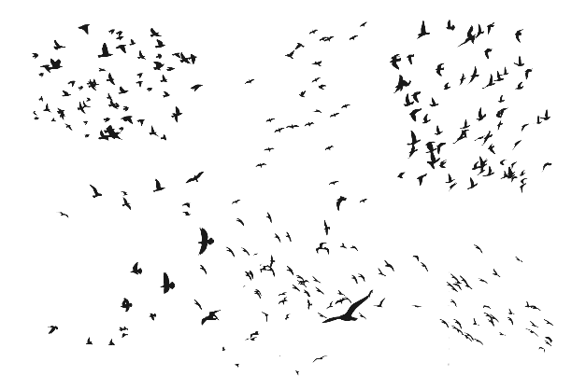
Figure 1 Flocks of birds

Boids
Boids is an artificial life computer program. The name “boid” corresponds to a shortened version of “bird-oid object” which refers to a bird-like object [2]. As with most artificial life simulations Boids is an example of emergent behavior. The complexity of Boids arises from the interaction of individual agents (the boids, in this case) adhering to a set of simple rules. The rules applied in the simplest Boids world are as follows:
- separation: steer to avoid crowding local flockmates;
- alignment: steer towards the average heading of local flockmates;
- cohesion: steer to move towards the average position (center of mass) of local flockmates.
More complex rules can be added, such as obstacle avoidance and goal-seeking.
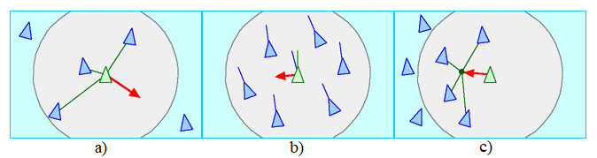
Figure 2 Boids rules: a) separation; b) alignment; c) cohesion.
Each boid has direct access to the whole scene’s geometric description, but flocking requires that it reacts only to flockmates within a certain small neighborhood around itself. The neighborhood is characterized by a distance (radius measured from the center of the boid) and an angle, measured from the boid’s direction of flight. Flockmates outside this local neighborhood are ignored. The neighborhood could be considered as a model of limited perception (as by fish in murky water) but it is probably more correct to think of it as defining the region in which flockmates influence a boids steering.
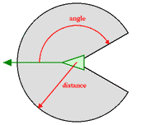
Figure 3 Boid neighborhood
In the Boids model interaction between simple behaviors of individuals produces complex yet organized group behavior. The Component behaviors are inherently nonlinear, so mixing them gives the emergent group dynamics a chaotic aspect. At the same time, the negative feedback provided by the behavioral controllers tends to keep the group dynamics ordered. The result is life-like group behavior. The movement of boids can be characterized as either chaotic (splitting groups and wild behavior) or orderly. Unexpected behaviors, such as splitting flocks and reuniting after avoiding obstacles, can be considered emergent.
The Boids model is an example of an individual-based model, a class of simulation used to capture the global behavior of a large number of interacting autonomous agents. Individual-based models are widely used in biology, ecology, economics, and other fields of study. The Boids framework is also often used in computer graphics, providing realistic-looking representation of flocks of birds and other creatures, such as schools of fish or herds of animals. The Boids model can be used for direct control and stabilization of teams in swarm robotics [3][4]. It can be also used for swarm optimization tasks [5].
At the time of the proposal, Reynold’s approach represented a giant step forward compared to the traditional techniques used in computer animation for motion pictures.

K-d tree
In computer science, a k-d tree (short for the k-dimensional tree) is a space-partitioning data structure for organizing points in a k-dimensional space. K-d trees are a useful data structure for several applications, such as searches involving a multidimensional search key (e.g. range searches and nearest neighbor searches). K-d trees are a special case of binary space partitioning trees.
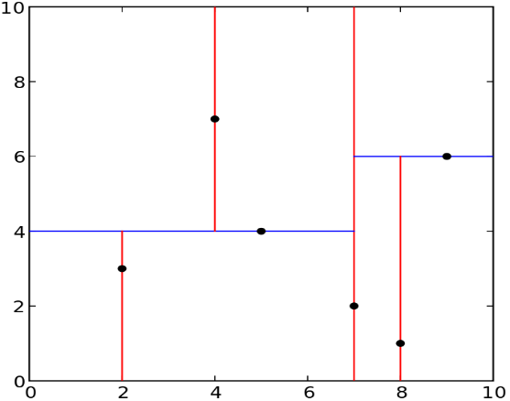
Figure 4 Decomposition of a 2-d tree
The k-d tree is a binary tree in which every leaf node is a k-dimensional point. Every non-leaf node can be thought of as implicitly generating a splitting hyperplane that divides the space into two-part, known as half-spaces. Points to the left of this hyperplane are represented by the left subtree of that node and points to the right of the hyperplane are represented by the right subtree. The hyperplane direction is chosen in the following way: every node in the tree is associated with one of the k dimensions, with hyperplane perpendicular to that dimension’s axis. So, for example, if for a particular split the “x” axis is chosen, all points in the subtree with a smaller “x” value than the node will appear in the left subtree and all points with larger “x” value will be in the right subtree. In such a case, the hyperplane would be set by the “x” value of the point, and its geometry normal vector would be the unit x-axis [6].

Construction
There are many different ways to construct k-d trees [7]. The canonical method of k-d tree construction has the following constraints:
- As one moves down the tree, one cycles through the axes used to select the splitting planes. For example, in a 3-dimensional tree, the root would have an x-aligned plane, the root’s children would both have y-aligned planes, the root’s grandchildren would all have z-aligned planes, the root’s great-grandchildren would all have x-aligned planes and so on.
- Points are inserted by selecting the median of the points being put into the subtree, concerning their coordinates in the axis being used to create the splitting plane.
This method leads to a balanced k-d tree, in which each leaf node is approximately the same distance from the root. However, balanced trees are not necessarily optimal for all applications.
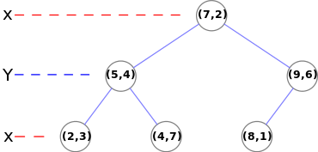
Figure 5 Example of a 2-d tree
Note that it is not required to select the median point. In the case where median points are not selected, there is no guarantee that the tree will be balanced. In the approach presented in this work, the quicksort algorithm is used for sorting the boids by the coordinate used for selecting the splitting plane. Quicksort is an efficient algorithm with an average performance $O\left(nlogn\right)$.

Nearest neighbor search
The nearest neighbor search (NN) algorithm aims to find the point in the tree that is nearest to a given input point. This search can be done efficiently by using the tree properties to quickly eliminate large portions of the search space [8].
Searching for the nearest neighbor in a k-d tree proceeds as follows:
- Starting with the root node, the algorithm moves down the tree recursively, in the same way, that it would if the search point were being inserted.
- Once the algorithm reaches a node, it checks that node point and if the distance is better, that node point is saved as the “current best”.
- The algorithm unwinds the recursion of the tree, performing the following steps at each node:
  - If the current node is closer than the current best, then it becomes the current best.
  - The algorithm checks whether there could be any points on the other side of the splitting plane that are closer to the search point than the current best. This is done by intersecting the splitting hyperplane with a hypersphere around the search point that has a radius equal to the current nearest distance. Since the hyperplanes are all axis-aligned, this is implemented as a simple comparison to see whether the distance between the splitting coordinate of the search point and the current node is less than the distance from the search point to the current best.
    - If the hypersphere crosses the plane, there could be a nearer point on the other side of the plane, so the algorithm must move down the other branch of the tree from the current node looking for closer points, following the same recursive process as the entire search.
    - If the hypersphere does not intersect the splitting plane, then the algorithm continues walking up the tree, and the entire branch on the other side of that node is eliminated.
- When the algorithm finishes this process for the root node, the search is complete.
Generally, the algorithm uses squared distances for comparison to avoid computing square roots. Additionally, it can save computation by holding the squared current best distance in a variable for comparison.
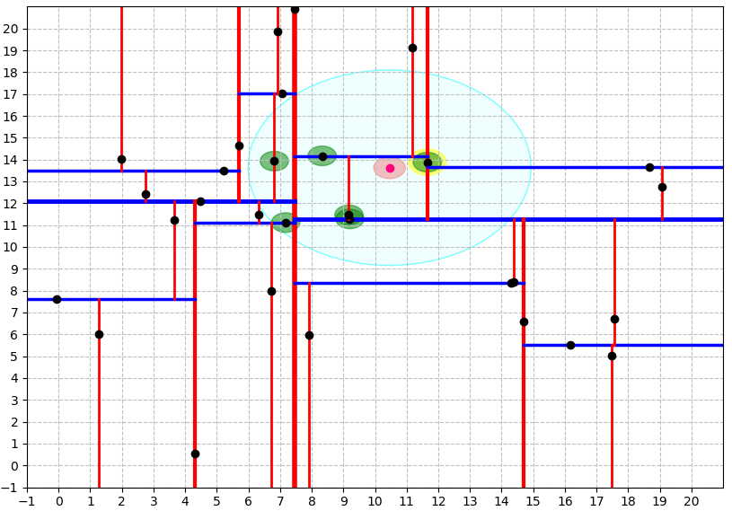
Figure 6 Nearest neighbors search for a given point
The algorithm can be extended in several ways by simple modifications. It can provide the k nearest neighbors to a point by maintaining k current bests instead of just one. A branch is only eliminated when k points have been found and the branch cannot have points closer than any of the k current bests. It can also be converted to an approximation algorithm to run faster. For example, an approximate nearest neighbor search can be achieved by simply setting an upper bound on the number of points to examine in the tree.
Approximate nearest neighbor is useful in real-time applications such as robotics, due to the significant speed increase gained by not searching for the best point exhaustively.
In this work, the exact nearest neighbor search algorithm is used. It is modified to perform a search in a defined radius as shown in Figure 6, where the cyan circle is formed around the pink boid of interest, and the boids found in the defined radius are marked with green circles.

Complexity
- Building a static k-d tree from n points has the following worst-case complexity:
- $O\left(n\log^{2}n\right)$ if an $O\left(nlogn\right)$ sort such as heapsort, merge sort or quicksort is used to find the median at each level of the nascent tree;
- $O\left(nlogn\right)$ if an $O\left(n\right)$ median of medians algorithm is used to select the median at each level of the tree [9];
- $O\left(knlogn\right)$ if $n$ points are pre-sorted in each of $k$ dimension using an $O\left(nlogn\right)$ sort such as heapsort, merge sort or quicksort [10];
- Inserting a new point into a balanced k-d tree takes $O\left(logn\right)$ time.
- Removing a point from a balanced k-d tree takes $O\left(logn\right)$ time.
- Finding one nearest neighbor in a balanced k-d tree with randomly distributer points takes $O\left(logn\right)$ time on average.

Implementation
The implementation of both approaches is carried out in the Python programming language. Visualization is done with the help of “p5” and “matplolib” visualization libraries, as well as the “NumPy” library that supports high-level mathematical functions. Creation and simulation of boids are supported by the “p5” library that provides high-level drawing functionality and enables the creation of simulations and interactive art using Python.

Brute force approach
Pseudocode:
The brute force approach is suffering from quadratic time complexity because while searching for nearest boids the distance from every boid to all other boids must be calculated. When the distance is compared with the defined radius the boid can be classified as a neighbor if it is less than the radius. When all the neighbors are found then the steering rules are applied and the steering forces are calculated for the currently chosen boid. The nested “for loops” and calculations that are done for every boid combination from the flock set are slowing down the algorithm in a quadratic manner as the number of boids increases.

Optimized approach
Pseudocode:
With modified nearest neighbor search the neighbors of the currently chosen boid can be found in an average optimal time of $O\left(logn\right)$. The total search time for every boid would be $O\left(nlogn\right)$ which is far lower than the brute force approach as the number of boids increases. When all neighbors are found, they are passed to the function that applies the rules and calculates the steering forces. With this approach, the nested for loops are avoided and the search time is fairly reduced with the use of k-d tree and nearest neighbor search algorithm.

Time analysis
In Table 1 the times required for evaluating one iteration in the loop are presented. One iteration in optimal approach consists of the creation of a k-d tree and then for every boid these steps are performed: searching for neighbors in the radius, applying the rules and performing the calculations for steering forces, updating the boids, and drawing the boids on canvas. In the brute force approach, the difference in the iteration loop is the absence of tree creation and the search algorithm works differently.
Table 1 Times required per iteration
Number of boids: | Optimal app. | Bruteforce app.
20 | 0.033 [s] | 0.078 [s]
40 | 0.11 [s] | 0.57 [s]
80 | 0.16 [s] | 0.97 [s]
120 | 0.26 [s] | 2 [s]
160 | 0.4 [s] | 3.6 [s]
200 | 0.54 [s] | 5.93 [s]
240 | 0.69 [s] | 8.56 [s]
280 | 0.82 [s] | 11.2 [s]

Conclusion
This work is one presentation of the vast applications of k-d trees and their efficiency. As can be seen from Figure 7 that with the implementation of a k-d tree and nearest neighbour search the evaluation time is significantly improved, which enables better and more consistent simulation close to the real-life phenomenon with the use of limited resources.
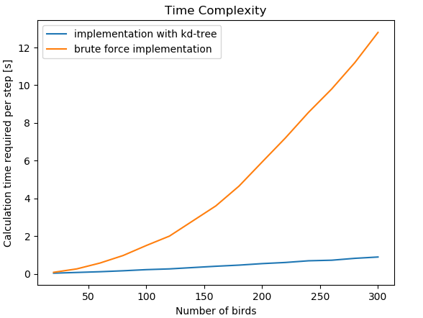
Figure 7 Time complexity comparison plot

References

[1] C. W. Reynolds, “Flocks-Hers-and-Schools,” vol. 21, no. July, pp. 25–34, 1987.
[2] A. Banks, J. Vincent, and C. Anyakoha, “A review of particle swarm optimization. Part I: Background and development,” Nat. Comput., vol. 6, no. 4, pp. 467–484, 2007, doi: 10.1007/s11047-007-9049-5.
[3] H. Min and Z. Wang, “Design and analysis of group escape behavior for distributed autonomous mobile robots,” Proc. - IEEE Int. Conf. Robot. Autom., pp. 6128–6135, 2011, doi: 10.1109/ICRA.2011.5980123.
[4] M. Saska, J. Vakula, and L. Preucil, “Swarms of micro aerial vehicles stabilized under a visual relative localization,” Proc. - IEEE Int. Conf. Robot. Autom., pp. 3570–3575, 2014, doi: 10.1109/ICRA.2014.6907374.
[5] Z. Cui and Z. Shi, “Boid particle swarm optimization,” Int. J. Innov. Comput. Appl., vol. 2, no. 2, pp. 78–85, 2009, doi: 10.1504/IJICA.2009.031778.
[6] J. L. Bentley, “Multidimensional binary search trees used for associative searching,” Commun. ACM, 1975, doi: 10.1145/361002.361007.
[7] M. de Berg, O. Cheong, M. van Kreveld, and M. Overmars, “Orthogonal Range Searching,” Comput. Geom., pp. 95–120, 2008, doi: 10.1007/978-3-540-77974-2_5.
[8] R. Panigrahy, “An improved algorithm finding nearest neighbor using Kd-trees,” Lect. Notes Comput. Sci. (including Subser. Lect. Notes Artif. Intell. Lect. Notes Bioinformatics), vol. 4957 LNCS, pp. 387–398, 2008, doi: 10.1007/978-3-540-78773-0_34.
[9] M. Blum, R. W. Floyd, V. Pratt, R. L. Rivest, and R. E. Tarjan, “Time Bounds for Selection,” vol. 1, pp. 448–461, 1973.
[10] R. A. Brown, “Building a Balanced k-d Tree in O(kn log n) Time,” 2014.

